|  |
| --- |
|  |
| Bookstore project |
| Documentation |

|  |
| --- |
| Viktor Ónodi-Kiss  3-26-2024 |

Contents

Web Application 2

Features 2

Installation 2

Usage 3

Technologies Used 7

Desktop Application 8

Features 8

Installation 8

Usage 9

Technologies Used 12

Admin Application 13

Features 13

Installation 13

Usage 13

Technologies Used 17

Addendum 18

License 18

Support 18

# Web Application

## Features

* Multiple page layout: There are 4 pages for the user to navigate all parts of the website.
* Randomly choosen „featured books” section: Every time the user refreshes the page, a new selection of 3 books are choosen for them randomly.
* Theme switch button: Located in the top-right corner, the „sun/moon” button allows for the users to switch between the (default) bright and dark themes. Their last choice is saved as a cookie, so that it stays the same after refreshing
* Read and Edit database: On the „Webshop” page the users can view the current inventory of the bookstore and even change the selection with the buttons on the left side. They can also put their items into a cart, following which they can either remove it or make a transaction. The later modifies the database, to decrease the quantity of the bought books by 1.
* Responsive design: The application is designed to work seamlessly across different devices and screen sizes.

## Installation

To run the Web Application locally, follow these steps:

1. Clone the repository from GitHub: git clone <https://github.com/Vikhun15/BookstoreProject.git>
2. Navigate to the project directory: BookstoreProject/
3. Open the BookstoreProject.sln project file in Visual Studio
4. Launsch the ClientWeb project
5. Open a web browser and navigate to http://localhost: 7261

## Usage

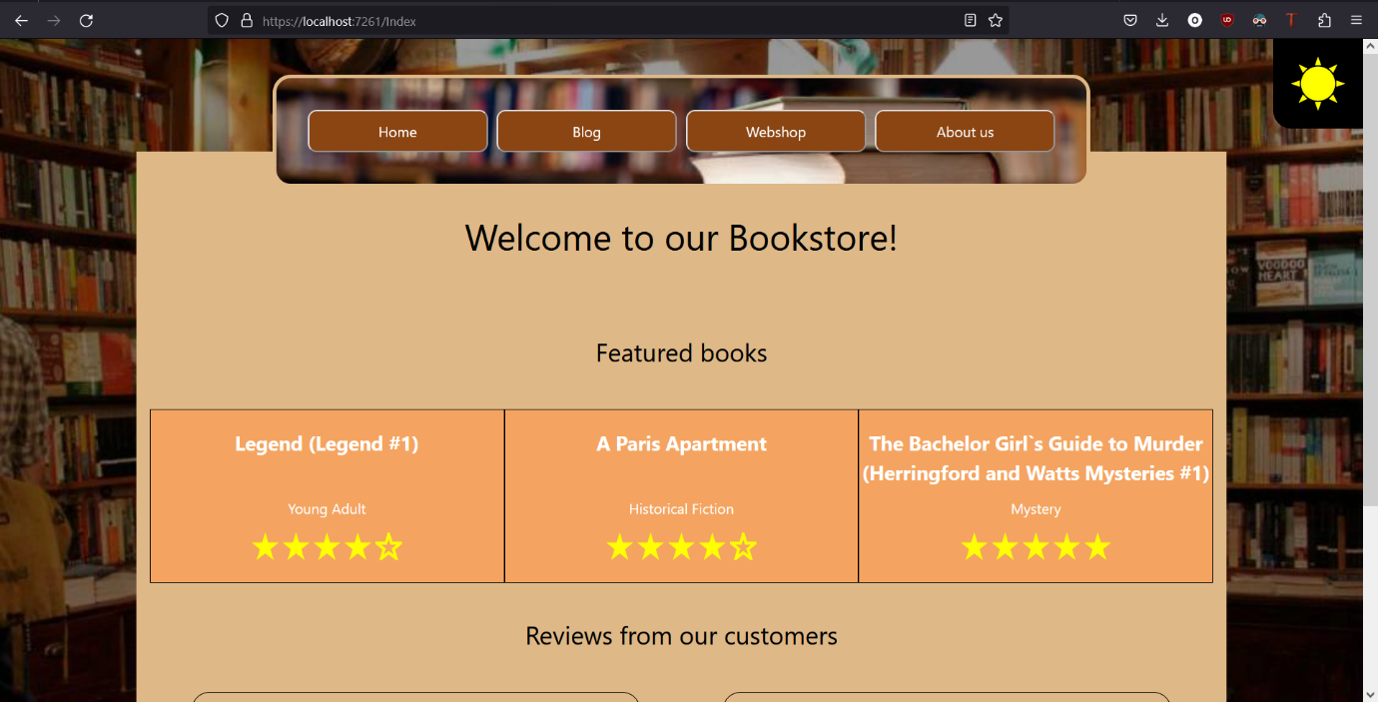

1. Figure: The default opening page

1. 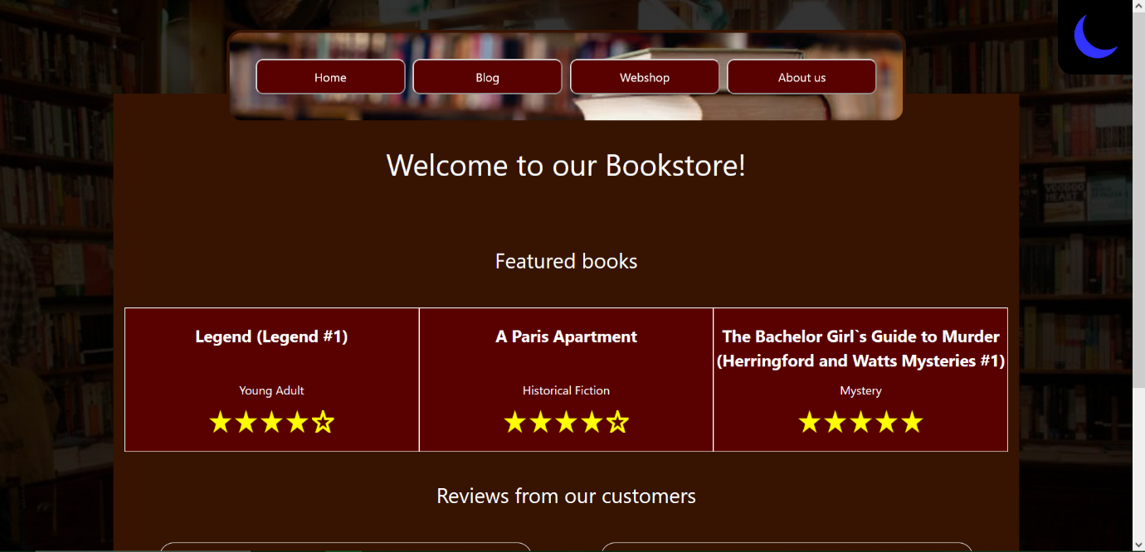Click on the button in the top right corner to switch the theme

2. Figure: The "dark" theme

1. You can navigate the pages on the navigation bar located at the top of the page
2. 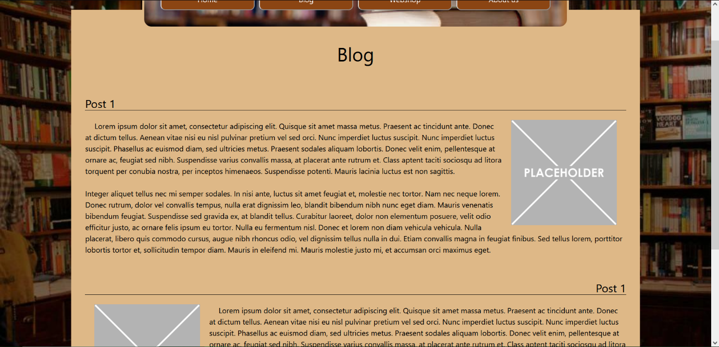Click the Blog button to load the Blog page, where you can find various blog posts

3. Figure: The Blog page

1. 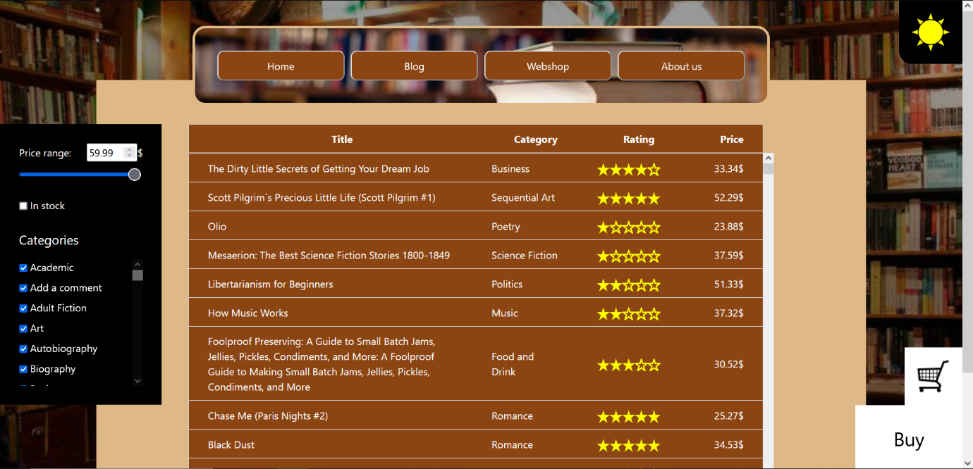Click the Webshop button to navigate to the webshop page of the store

4. Figure: The Webshop page

1. On the webshop page you can click any row to make them selected (marked by the purple background color)
2. 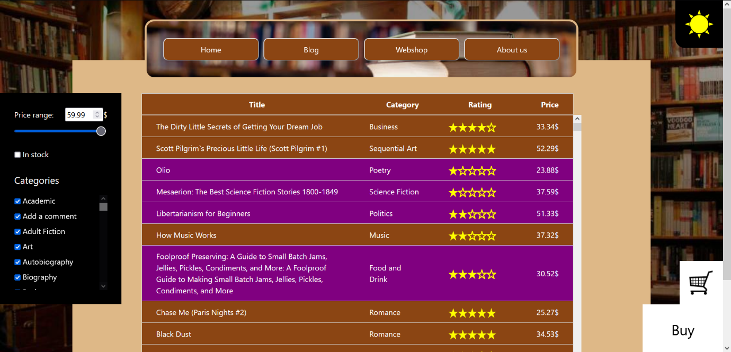You can also change the price range by either moving the slider on the right, or changing the value in the textbox (either way, the value in both will match)

5. Figure: Users can select rows (marked by the purple background)

1. 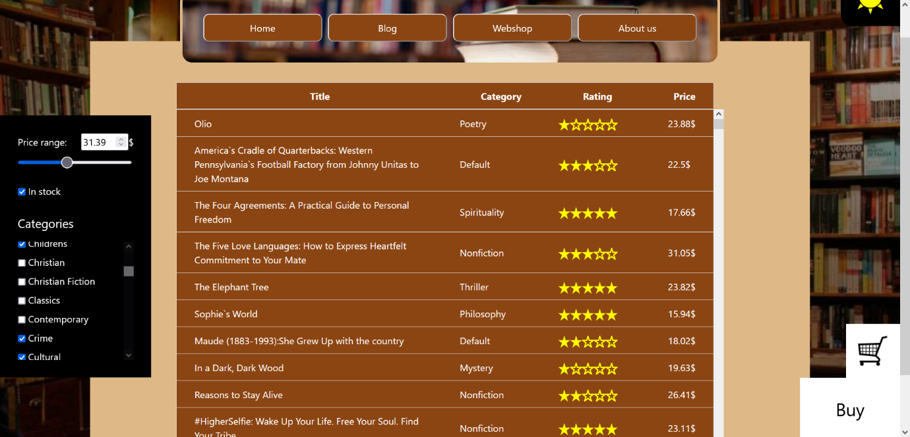You can choose to only show the books that are in stock, or only the categories that you want to see

6. Figure: The users can change the items shown in the table

1. Use the Buy button to add the selected items to the cart.
2. 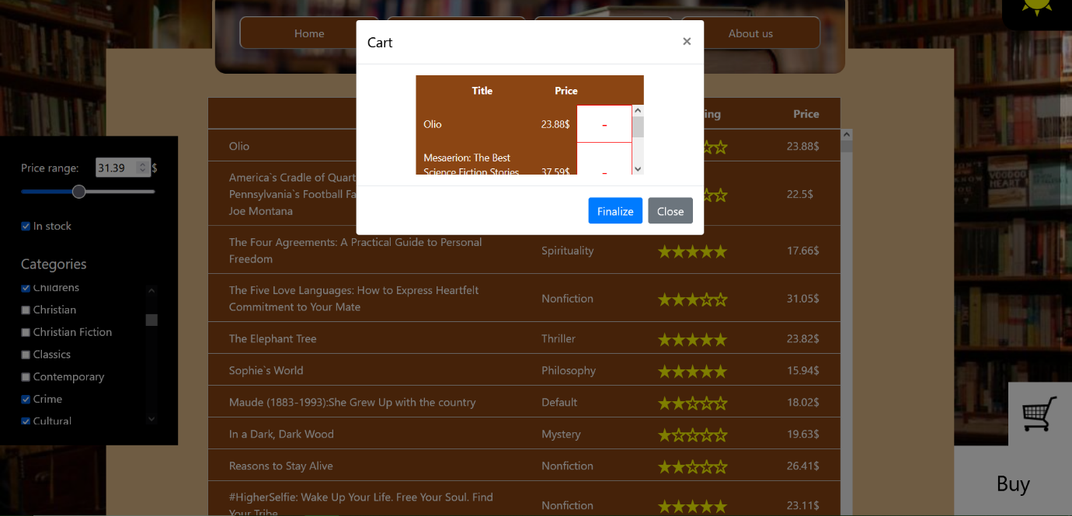Use the button labeled by a shopping cart to view the items in your cart

7. Figure: The cart

1. In the shopping cart, you can remove items in your cart by clicking the red sign next to the items
2. 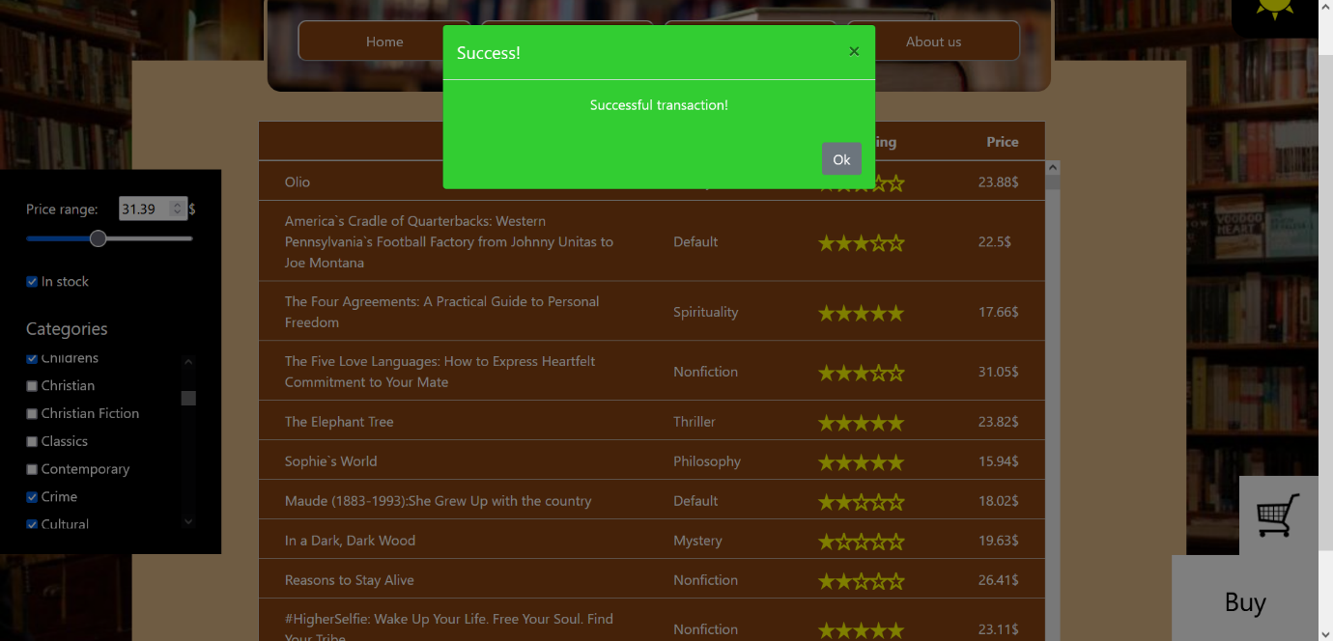By clicking the „finalize” button, you can finalize the transaction and update the database

8. Figure: The modal window showing upon a successfull transaction

1. Using the navigation panel, you can navigate to the „about” page

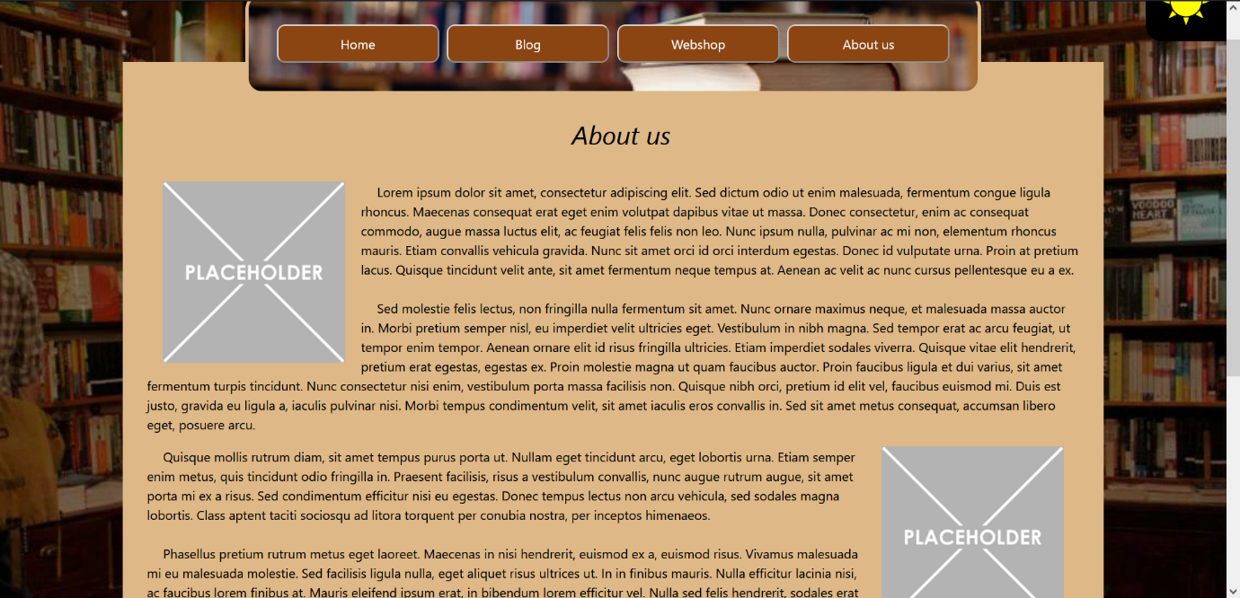

9. Figure: The About us page

## Technologies Used

* Frontend: HTML, Razor, Javascript, JQuery
* Backend: ASP.NET Core, C#
* Database:
  + PostgreSQL database server hosted on ElephantSQL [1]
* Styling: CSS Modules, Bootstrap
* Framework: .NET framework 8.0

# Desktop Application

## Features

* User authentication: Users can sign up for an account or log in with existing credentials.
* Dynamic selectors for table: The users can (de)select categories, limit the maximum price range, show only books that are in stock or search for specific keywords in the titles
* Users can add books to their carts and also remove them
* Users can finalize the transaction if they are logged in

## Installation

To run the Desktop Application, follow these steps:

1. Clone the repository from GitHub: git clone <https://github.com/Vikhun15/BookstoreProject.git>
2. Navigate to the project directory: BookstoreProject/
3. Through Visual Studio:
   1. Open the BookstoreProject.sln project file in Visual Studio
   2. Launch the ClientApp project
4. Through executable
   1. Navigate to the executable directory: BookstoreProject/ClientApp/bin/Debug
   2. Launch the ClientApp.exe file

## A screenshot of a computer Description automatically generatedUsage

10. Figure: ClientApp startup window

1. 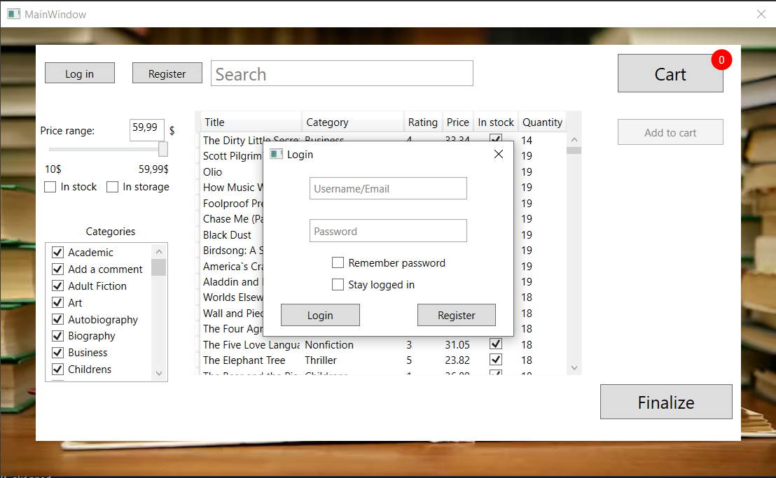Log in with existing credentials. Users can also check the „Remember password” box so the program fills in the password at the next login upon entering the correct username, and also check the „stay logged in” box to stay loggged in even after closing the application

11. Figure: The login window

1. 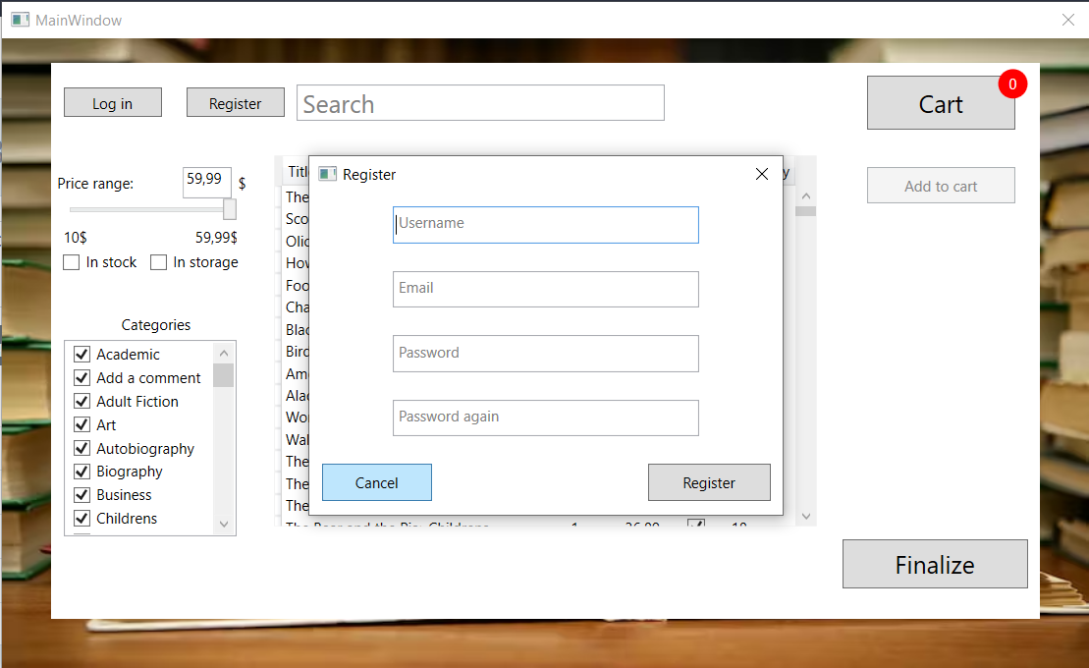Sign up for a new account

12. Figure: The register window

1. 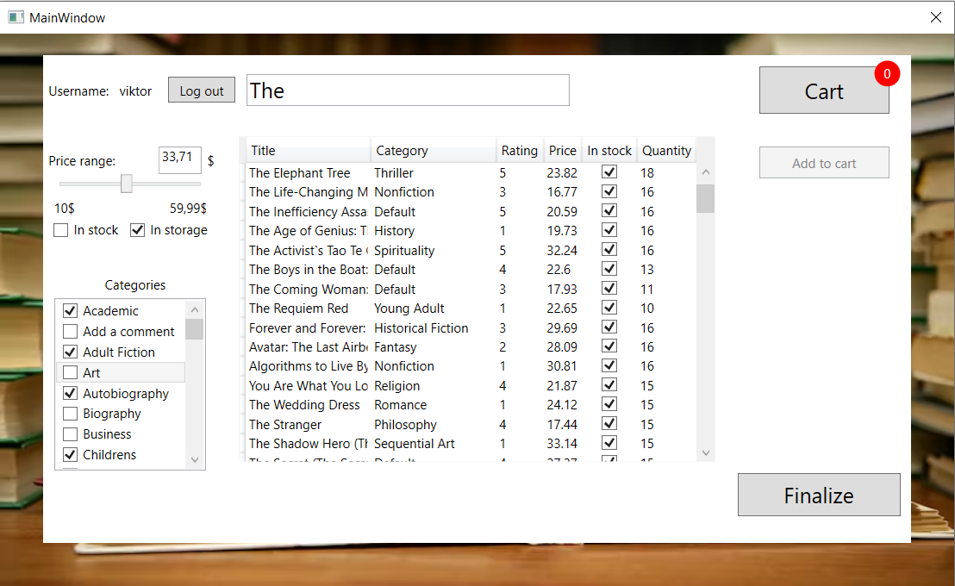Specify the shown rows in the table

13. Figure: The users can change the maximum price range, selected categories and search in titles

1. 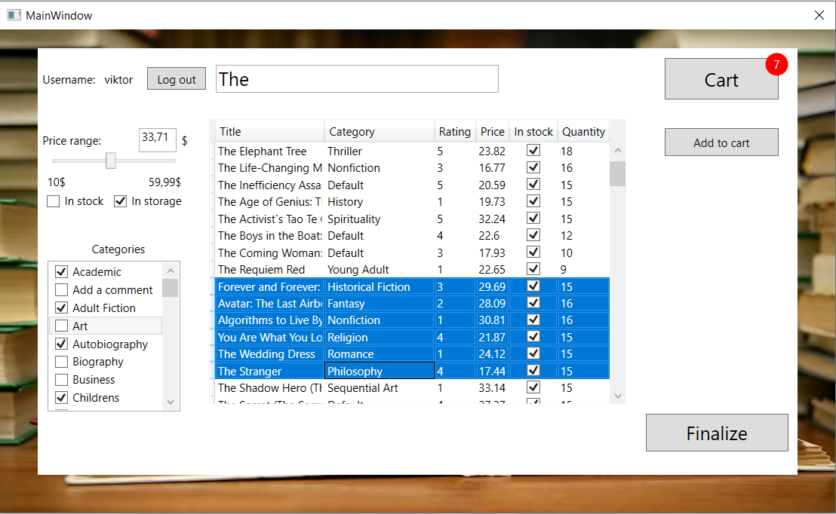Add selected items to the cart

14. Figure: Upon selecting items, the "add to cart" button will be enabled

1. 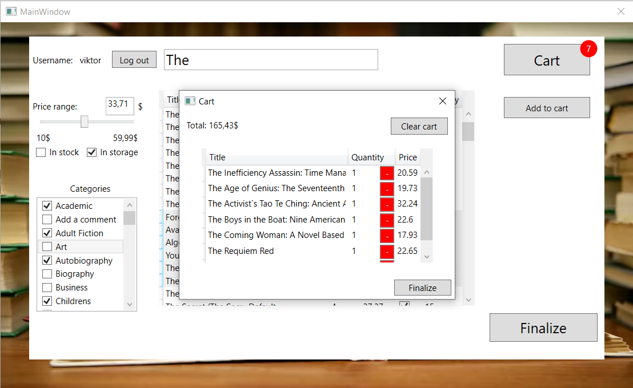Finalize the transaction by opening the cart. If the user is not logged in, then they will be asked to log in before proceeding.

15. Figure: Users can remove books from the cart or finalize the transaction

## Technologies Used

* Frontend: WPF
* Backend: C#
* Database:
  + PostgreSQL database server hosted on ElephantSQL
  + SQLite local database for storing login details
* Authentication: Through PostgreSQL database

# Admin Application

## Features

* User authentication: Users with admin priviliges are required to log in with existing credentials.
* Multiple modes: Users can switch between „register” (meant for use in a cash register terminal) and „manage” (meant to be used by the manager as an inventory management system) modes
* Users in Manage mode can create, read, update and delete items
* Users in Register mode can read books and reduce their quantities
* The application will open in the last used mode

## Installation

To run the Admin Application locally, follow these steps:

1. Clone the repository from GitHub: git clone <https://github.com/Vikhun15/BookstoreProject.git>
2. Navigate to the project directory: BookstoreProject/AdminApp/AdminAppExe
3. Launch the AdminApp.exe executable

## Usage

1. 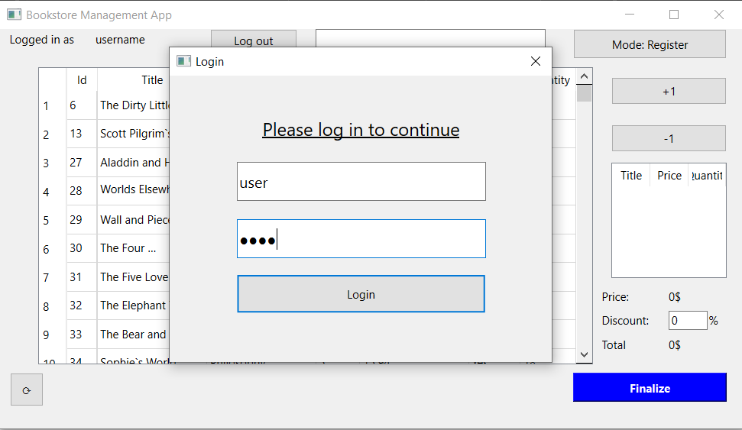The users have to log in immediately upon launching the application if they want to proceed

16. Figure: The login window in Register mode

1. 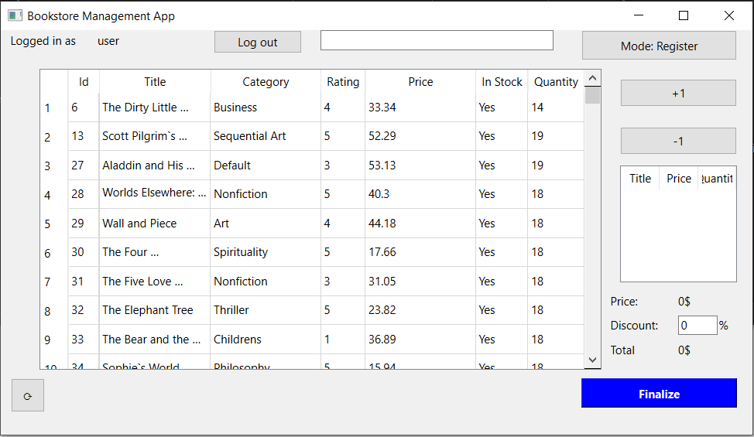Upon logging in, users gain full access to the application

17. Figure: The Register mode

1. 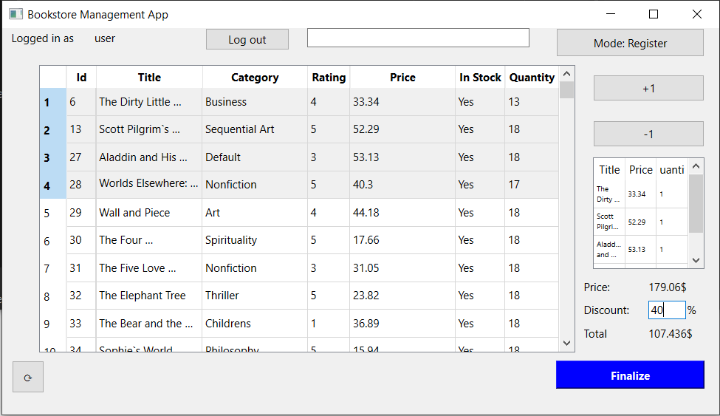In Register mode, users can select books and add them to the cart, in accordance with the physical purchase

18. Figure: The entries have been added to the cart along with a 40% off discount

1. 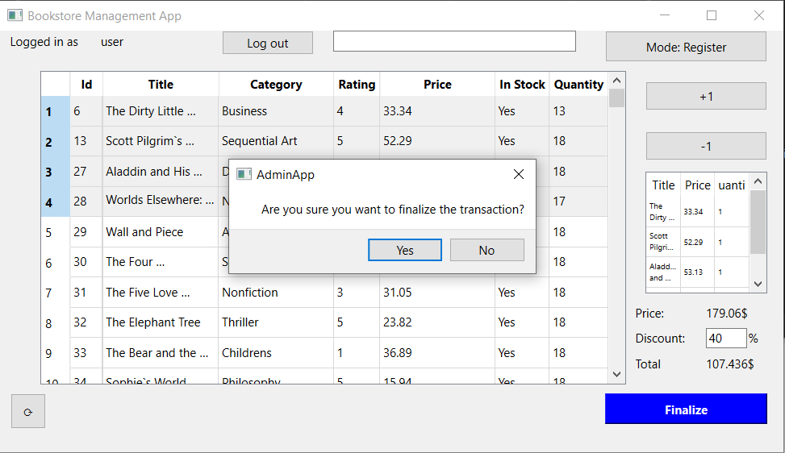Upon clicking the „finalize” button, the user will get a prompt to decide whether if they want to proceed

19. Figure: The messagebox showing upon clicking the "Finalize" button

1. 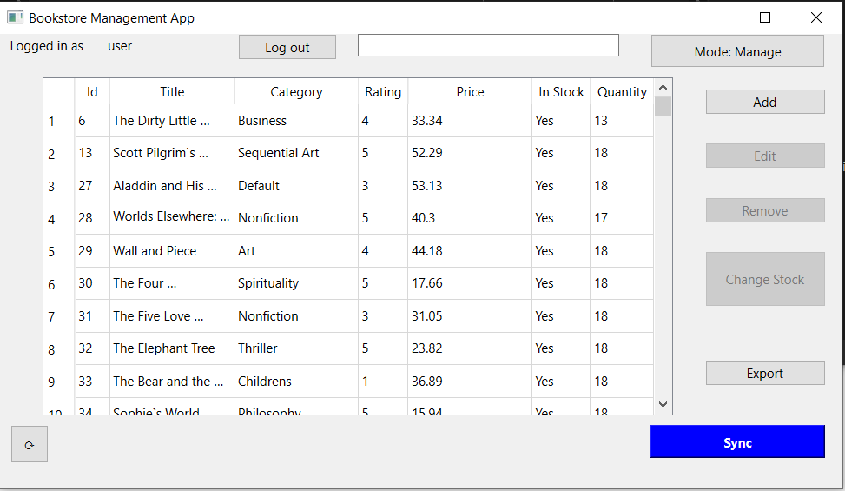The user can switch modes, which will not require the user to log in again

20. Figure: The Manage mode

1. 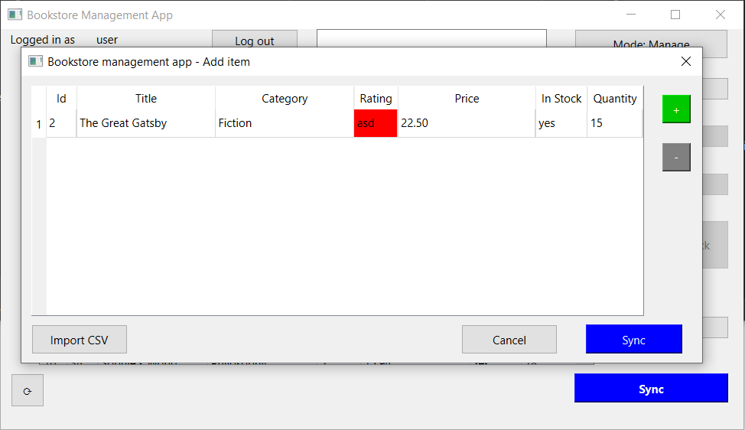In the Manage mode, users can add new items to the table

21. Figure: The "Add" window

1. 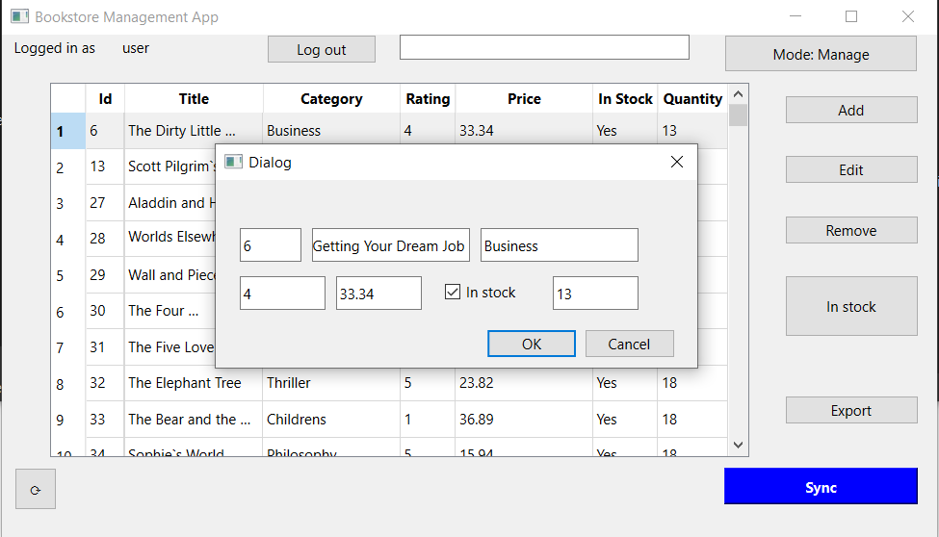Users can also edit items by clicking the „edit” button, and remove entries by clicking the „remove” button

22. Figure: The „Edit” window

1. 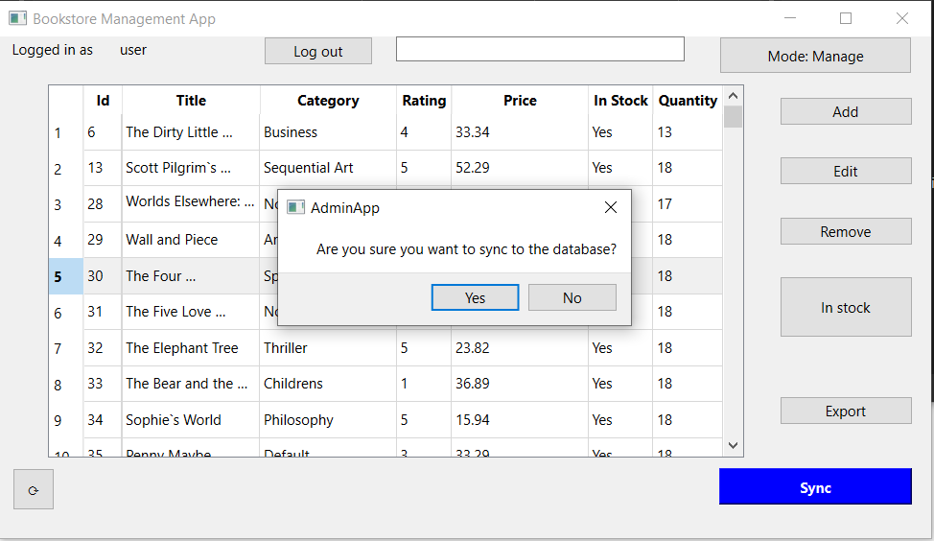By clicking the „Sync” button, the user can overwrite the database with their own table. The application will ask for confirmation in a popup messagebox.

23. Figure: The messagebox waiting for confirmation

## Technologies Used

* Frontend: Qt6, QML
* Backend: C++
* Database:
  + PostgreSQL database server hosted on ElephantSQL
  + SQLite database for local settings
* Authentication: Through PostgreSQL database

# Addendum

## License

The Bookstore project is licensed under the MIT License. See the LICENSE file for details.

## Support

For questions, issues, or feature requests, please contact Viktor Ónodi-Kiss at vikonody09@gmail.com.

1. <https://www.elephantsql.com/>